

*"A journey of a thousand miles begins with a single step,"* Lao Tzu

**Croakus: An Introduction**

In the murky depths of the swamp, amidst the chorus of croaks and chirps, there emerged a legend – Croakus, the renegade frog. Rising from the shadows of the lily pads, Croakus possessed an unyielding ambition, a determination that surpassed the boundaries of the boggy terrain he called home.

As the mist lifted, revealing his emerald silhouette against the dawn's light, Croakus set forth on a daring quest unlike any seen before in the swamp. His goal? To dominate the cryptocurrency market, leaving all other meme coins gasping for air in his wake. With eyes that gleamed with a fervour unmatched and a tongue sharp as a serpent's, he vowed to elevate himself beyond the confines of the marsh, transcending into the realm of digital wealth.

But one should never underestimate the power and determination of Croakus. His legend echoed through the reeds and rushes, whispered among the creatures of the swamp who revered him as their fearless leader. To them, he was more than just a frog; he was a symbol of boldness and courage, a beacon of hope in the murky waters.

With each leap, Croakus defied the odds, his eccentric appearance belying the shrewdness that lay within. His webbed feet propelled him forward, navigating through the treacherous currents of uncertainty with finesse. He was a warrior amphibian, unyielding in his pursuit, undeterred by the skeptics and naysayers who dared to challenge his reign.

Croakus did not suffer fools gladly, his croak a battle cry that echoed through the swamp, warning all who dared to stand in his path. Yet, beneath the surface of his bold exterior lay a cunning intellect, a strategic mind that plotted and planned each move with precision.

So, as the sun sets on the horizon, casting its golden glow upon the water's surface, remember this: never underestimate the prowess of Croakus, for he is more than just a frog – he is a force to be reckoned with, a legend in the making, destined to leave his mark on the cryptocurrency market and beyond.

**Croakus Token: It's Just the beginning**

In the vast landscape of cryptocurrency innovation, Croakus Token emerges not merely as a fleeting meme coin, but as the cornerstone of a grander vision. Our journey begins with a strategic decision that sets us apart – the choice to launch on Coinbase's Layer 2 Base network, a decision that speaks volumes about our commitment to accessibility, scalability, and sustainability.

While Ethereum and Binance Smart Chain reign as titans in the crypto realm, we have opted for a different path, leveraging the solidity and reliability of Coinbase's Layer 2 Base network. Built upon the Ethereum Network, this layer offers a bedrock of security and scalability, ensuring that Croakus Token is launched on a foundation that has already weathered the storms of volatility and uncertainty.

What sets Layer 2 Base apart is its ingenious architecture, which mitigates the congestion and exorbitant fees often associated with Ethereum transactions. By operating on a Layer 2 network, purchasing Croakus Token incurs only a fraction of the network fees compared to Ethereum, making it a more accessible and cost-effective option for investors and enthusiasts alike.

Phase one marks just the beginning of our journey. With the successful launch of Croakus Token on Coinbase's Layer 2 Base network, we pave the way for phase two – a quantum leap towards greater autonomy and sustainability. In this phase, we envision the creation of a native blockchain and coin, underpinned by a Proof of Stake (PoS) consensus mechanism.

PoS not only enhances security and efficiency but also aligns with our commitment to environmental responsibility. Unlike the energy-intensive Proof of Work (PoW) chains, PoS offers a greener alternative, reducing our carbon footprint while ensuring the integrity of our blockchain.

But our ambitions extend far beyond the realm of blockchain technology. Phase three heralds a new era of innovation, as we unveil a decentralized exchange (DEX), empowering users to trade the blockchain's native coin and other digital assets with unprecedented freedom and security.

This will lead into phase four where we envisage the integration of Web3 commerce and a plethora of other features, fostering a vibrant ecosystem that transcends traditional boundaries whilst maintaining our environmentally friendly approach to not just the digital currency industry, but the future web3 businesses we will bring into fruition.

As we embark on this odyssey of innovation and transformation, one thing remains certain – Croakus Token is not just a token; it's a symbol of resilience, adaptability, and boundless possibility. Join us as we leapfrog into the future, charting a course towards a more inclusive, sustainable, and prosperous tomorrow.

**Tokenomics: Coin distribution**

As the quintessential embodiment of grassroots collaboration, Croakus places control firmly in the hands of its community members, fostering a spirit of inclusivity and empowerment. With the majority of its tokens listed on Uniswap, Croakus symbolizes the democratization of finance, providing equal opportunities for all to participate in the ecosystem.

After the deployment of Croakus’s 1 Trillion tokens, our tokenomics will be meticulously structured to ensure stability, sustainability, and equitable distribution of tokens. Let's delve into the breakdown:

**1. Token Founders Allocation (5%):** A small but crucial portion of the token supply, comprising 5%, will be allocated to the founders of Croakus Token. This allocation serves as a reward for their visionary leadership, tireless dedication, and pioneering spirit in bringing the project to fruition. It also aligns their interests with the long-term success and growth of the ecosystem, fostering a symbiotic relationship between founders and the community.

**2. Project Development (10%):** Recognizing the importance of continual innovation and enhancement, a significant portion comprising 10% of the token supply will be dedicated to project development. These tokens will fuel the ongoing evolution of Croakus Token, enabling us to enhance functionalities, expand features, and explore new avenues of growth. From research and development to marketing and partnerships, this allocation ensures that we remain at the forefront of technological advancement and community engagement.

**3. Liquidity Pool (85%):** Liquidity is the lifeblood of any thriving ecosystem, and as such, 85% of the token supply will be allocated to a Liquidity Pool. These tokens will be locked away in a decentralized liquidity protocol, providing stability, depth, and efficiency to the trading environment. By facilitating seamless token swaps and reducing slippage, the Liquidity Pool ensures a smooth and frictionless user experience for traders and investors alike.

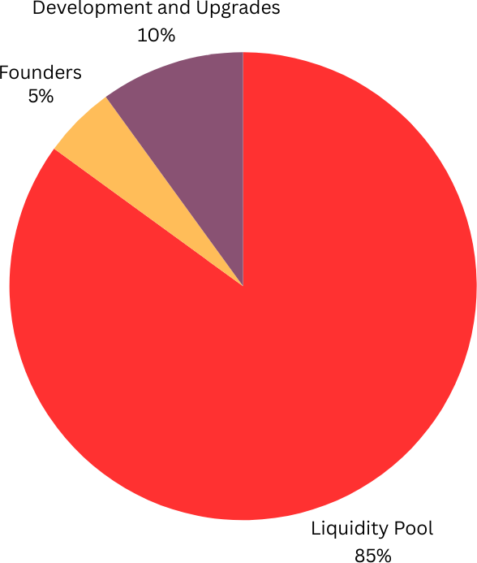

In summary, Croakus Tokenomics embodies our commitment to transparency, fairness, and sustainability. By allocating tokens strategically across various stakeholders, we strive to create a robust and resilient ecosystem that stands the test of time. Together, we leapfrog into the future, guided by the principles of innovation, collaboration, and community empowerment. Join us on this exhilarating journey as we redefine the possibilities of decentralized finance and pave the way for a brighter tomorrow.

**Roadmap: The four-step process**

The Croakus Meme Coin roadmap, where innovation meets community-driven progress. Explore our journey from inception to market presence, as we outline key milestones and initiatives shaping the future of decentralized finance. Join us as we leapfrog into a new era of digital currency innovation.

Phase 1: Establishing Presence

* Creating the Croakus website, providing a central hub for information and updates.
* Launching the official Twitter page for the Croakus community, fostering communication and engagement.
* Establishing a Telegram group for Croakus Meme Token, facilitating real-time discussions and support.
* Drafting and publishing the Croakus White Paper, outlining the project's vision, mission, and technical details.
* The Croakus Meme Coin project prioritizes security and stability by implementing an audited contract script meticulously scrutinised to meet the highest standards of reliability.
* Deploying the Croakus token on Base’s layer two network with a fixed supply of one trillion tokens. In the name of transparency, all permissions have been removed.
* listing Croakus on CoinGecko and CoinMarketCap websites, increasing visibility and credibility within the cryptocurrency community.
* Create a LP (Liquidity Pool) on Uniswap.
* Creating a decentralized exchange (DEX) with three features for the Croakus ecosystem, stake and earn, stake and burn and stake and churn.

**Phase 2: Blockchain Development**

* Initiating the development of a native blockchain and coin, adopting a Proof of Stake (PoS) consensus mechanism.
* PoS enhances security, efficiency, and environmental responsibility compared to energy-intensive PoW chains.
* Demonstrating commitment to sustainability by reducing the carbon footprint of our blockchain operations.

**Phase 3: Unveiling Innovation**

* Introducing a decentralized exchange (DEX), empowering users to trade the native coin and other digital assets securely and freely.
* Introduce two new tokens: a governance token and a meme coin, accessible through purchase or staking rewards.
* Pioneering a new era of innovation, offering users unprecedented freedom and security in their digital asset transactions.

**Phase 4: Integration of Web3 Commerce**

* Integrating Web3 commerce and a range of additional features into the native coin ecosystem.
* Fostering a vibrant ecosystem that transcends traditional boundaries, promoting accessibility and inclusivity.
* Maintaining an environmentally friendly approach, ensuring sustainability in the digital currency industry and future Web3 businesses.

Embark on an exciting journey with Croakus Meme Coin as we revolutionize the digital currency landscape. From our humble beginnings establishing a vibrant community to deploying our own blockchain and listing on premier exchanges, every milestone represents a step towards our vision of a decentralized, sustainable future. Join us as we pioneer innovation, empower our community, and redefine the possibilities of meme coin technology. The adventure awaits – hop on board today!

<https://www.croakus.xyz>